The Sports Training Planner was written by a former programmer for a large global communications company and a soccer coach for over 20 years. In other words, an application written by a soccer coach. After writing the application, it was discovered that the philosophy used to write the application was appropriate for most team sports. It was written with the idea that the coach had control of the content and freedom to use or not use some of the application features in a manner which is simple and easy to understand.

Getting Started
After installing the application, start it and the following screen will appear.
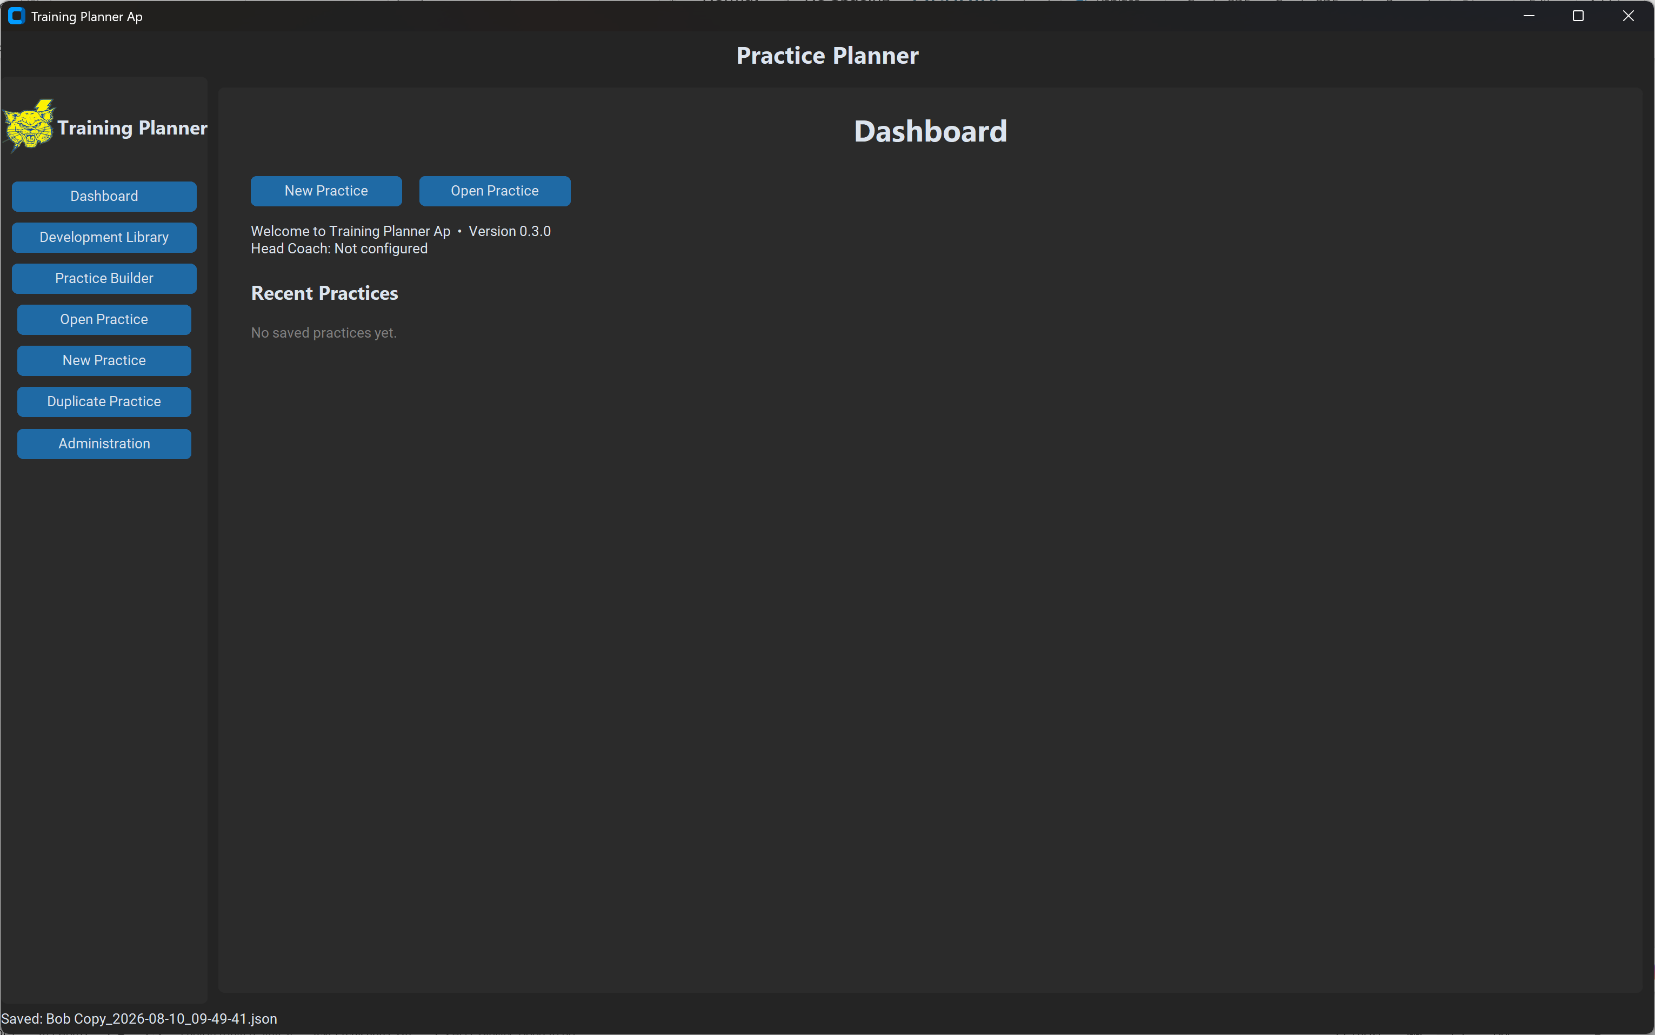
At the top is the title bar. This is configurable by clicking on the “Administration” button. On the left side is the planning menu. Dashboard (this screen), Development Library brings up the drills created by the user, Practice Builder which is a list of blocks containing drills and assignments (if desired), Open Practice which will open the system file search where it is possible to select a previously saved practice session, New Practice appears is two places on this screen and is used to set a new practice session, Duplicate Practice where you will be able to duplicate a template practice created earlier, Administration – this page will be discussed later.
All of the drills in this demonstration were created as a testing bed for soccer.
Screens

Development Library
You will be able to see a list of buttons showing the Practice Blocks.
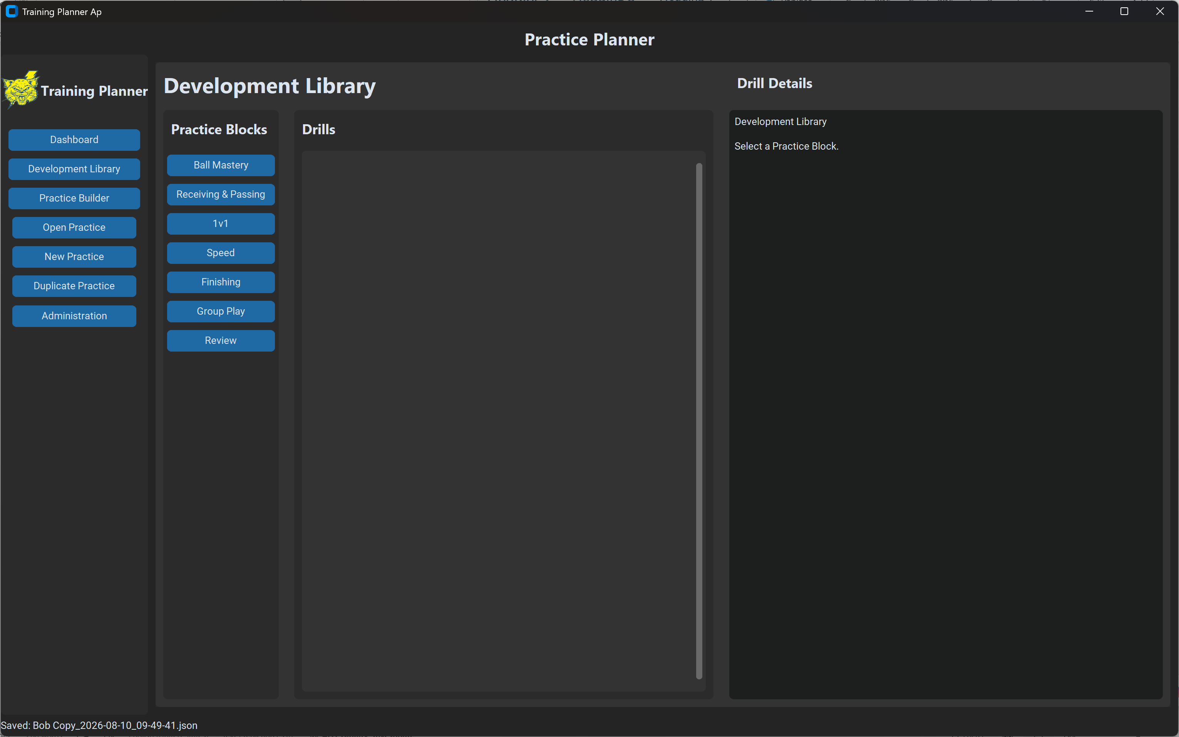
Clicking on the block will create a list of drills in the center menu bar associated with that Practice Block
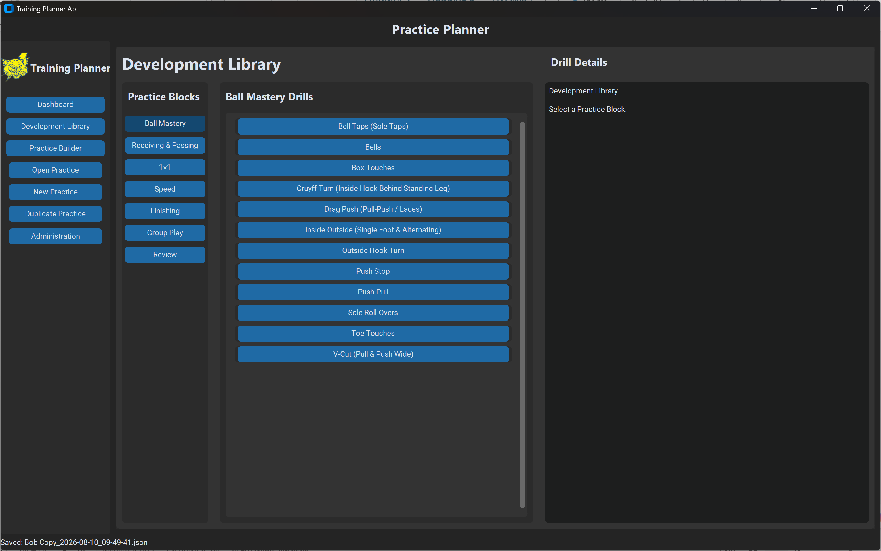

Clicking on the drill in the center menu bar will generate a description of that drill with coach focus, directions and other information.
` 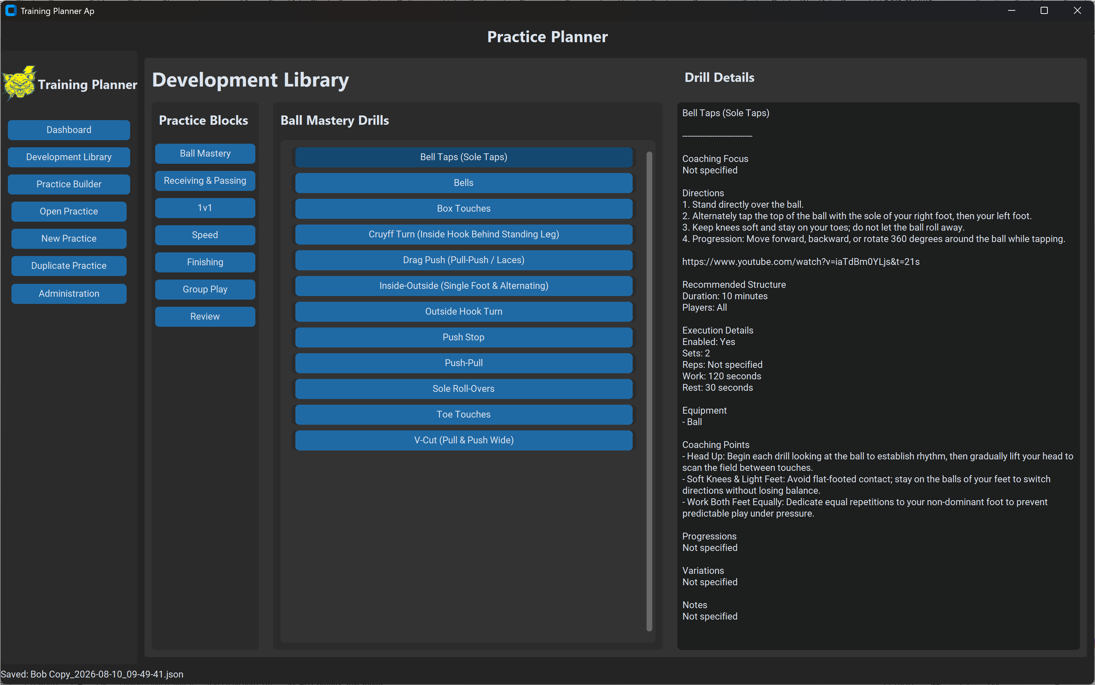
All of the information and labels are created by the user from the Administration page.

